

Committee Member

Address

Rochester, NY Zip Code

January 2, 2025

Dear Committee Member,

The incoming Trump administration poses a significant threat to the Rochester community, and we need experienced, capable Democratic legislators at every level of government. City Council is a serious job that requires serious work. My experience show that I am prepared to do this work and ready to fight for our community. That’s why I’m asking you to support me in the upcoming Democratic Party designation process as I seek re-election to City Council.

I’m the Chief Impact Officer at Foodlink. For over fifteen years I’ve helped nourish this community through impactful program development. I am responsible for developing this region’s only mobile grocery and cook apprenticeship program. Moreover, when COVID shut down our local economy, I was on the front lines every day ensuring that people had access to quality, affordable food.

Beyond my day job, I’ve served you as a City Councilmember at-large since 2018 and Finance Committee chair since 2022. My legislative work has improved the economic and environmental health of our community. I’ve made sure we’ve effectively spent every single American Rescue Plan dollar we’re owed, including $20+ million replacing lead water service lines across Rochester. I helped to develop and fund an Urban Forestry Master Plan that will root our green infrastructure, plant thousands of new trees, and make Rochester a haven in a changing climate. I am passionate about work that builds up our infrastructure *and* improves our community’s health.

In my tenure as Finance Chair, our bond rating has improved and we’ve passed balanced budgets without raising taxes. I’ve staunchly supported small businesses in many ways, including investing in our Public Market as a business incubator and helping to make Rochester the only upstate city where people can use SNAP benefits on hot, nutritious food.

Health goes beyond water and food. I banned conversion therapy in Rochester, co-wrote legislation that made the police department more accountable than ever before, and served on the board of our library system that has made information increasingly accessible. Most recently, I led the creation and approval of Roc Vision Zero, an ambitious plan to eliminate traffic fatalities that relies upon intensive coordination between every City department and many community-based organizations.

Bond ratings and intragovernmental coordination don’t make for great campaign slogans. But they are fundamental to who I am as a leader in our community and who I’ve been as your voice on City Council for serious, impactful, long-term work. This is a critical election and its outcome will determine if we can continue to make smart investments in environmental, economic and community health. This work will be harder than ever before during Trump’s second term, but I am ready for the fight.

I love Rochester and have spent my entire adult life serving this community. My wife and I are raising our two children here, and our oldest will be entering Kindergarten in RCSD this fall. With your support, I will continue to serve and will work as hard as I can to make Rochester the best place it can be for everyone.

Sincerely,

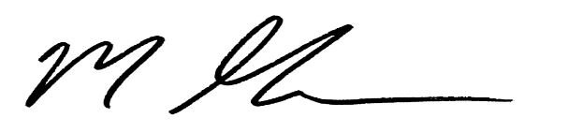

13 Greenwood St

Rochester, NY 14608

MitchforRochester.com

Mitch Gruber